Rachael Won
11/21/25
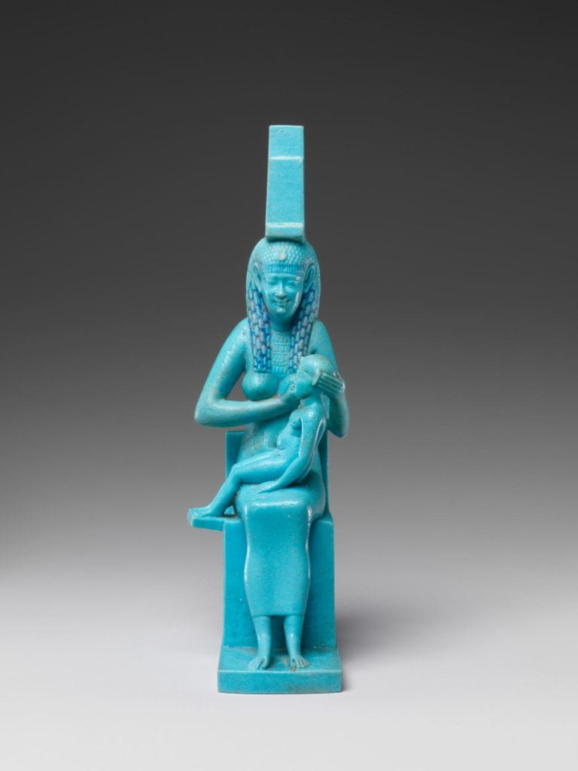
Statuette of Isis with the infant Horus, 332-30 BCE, Faience, 6 11/16 x 2 x 3 1/16 in, The Metropolitan Museum of Art

Divine Egypt is an exhibit that showcases the different ways ancient Egyptians showed their appreciation to the deities they believed in. Out of the many different deities and objects I saw, the beautiful and bright shade of blue drew me to the Statuette of Isis with the infant Horus. This motif of the goddess Isis nursing or suckling infant Horus was common throughout ancient Egyptian statues and art because it was a powerful symbol of rebirth. I was also drawn to this object because I could notice how important this motif was to ancient Egyptian art and mythology due to the many iterations of the same pose, all bearing the same deep meaning behind rebirth and motherhood.

One of the factors that made this object stand out from the rest of the depictions of Isis and Horus was the bright blue color of the faience and how vibrantly it was able to be preserved. Before even diving into the techniques behind faience, the color itself serves as an important symbol. The blue color was created to simulate stones like turquoise, symbolizing “fertility, life, and the gleaming qualities of the sun.” Even just by the color, this statuette holds great significance in ancient Egyptian culture. When we look into the technique behind faience, the bright blue color comes from the addition of copper into the material, and the glaze on the surface is done in the firing process, with the alkali and the lime reacting with the silica. This technique and material of faience interested me because it is not regular clay and can not be used in the same way traditional clay is used. Faience was a material commonly found in amulets, beads, and statuettes or small figurines. By looking at the importance behind the color and technique used and the meaning behind the motif of the statuette, we assume that this piece was highly symbolic both divinely and culturally.

The pose of Isis and Horus symbolizes rebirth because during this time, her qualities as a life-giver and protector were the most valued and sought after. These qualities were not always the most popular, but they began to gain traction and popularity later, leading to the popular iconography we know today, Isis with the infant Horus. This depiction of Isis was one of the most popular and favorite representations of her because of the symbolism and meaning of motherhood, protection, and divine kineship behind the iconography. This iconography was also an inspiration and reference for the Christian iconography of the Virgin Mary. Although not directly stated, the heavy similarities between the poses and the symbols behind the two figures lead historians to believe that there was some form of cultic continuity between the cult of Mary and that of Isis. The motifs found in both have a mother figure, the son, and the nursing aspect.

Overall, I believe that this statuette was a very important aspect to include in the Divine Egypt exhibition. The piece not only shared the very specific techniques behind faience, but also revealed how much ancient Egyptians looked up to Isis because of the various reiterations of the same iconography of Isis with infant Horus that held the important symbolism of rebirth. The Statuette of Isis with the infant Horus was placed along other pieces with the same iconography of Isis and Horus, so I was able to see the different materials and ways ancient Egyptians depicted this goddess.

References
Clark, Charlotte R. “The Egyptian Mother Goddess.” The Metropolitan Museum of Art Bulletin 4, no. 9 (1946): 240–42. https://doi.org/10.2307/3258098.
Higgins, Sabrina. “Divine Mothers: The Influence of Isis on the Virgin Mary in Egyptian Lactans-Iconographhy,” Journal of the Canadian Society for Copticc Studies 3-4 (2012): 71-90. https://www.researchgate.net/publication/312192708_Divine_Mothers_The_Influence_of_Isis_on_the_Virgin_Mary_in_Egyptian_Lactans-Iconography
Moss, Kelly A. , 2017. "The Development and Diffusion of the Cult of Isis in the Hellenistic Period." Order No. 10281055, The University of Arizona. https://www.proquest.com/dissertations-theses/development-diffusion-cult-isis-hellenistic/docview/1909315562/se-2.
Noble, Joseph Veach. “The Technique of Egyptian Faïence.” American Journal of Archaeology 73, no. 4 (1969): 435–39. https://doi.org/10.2307/503999.
Riccardelli, Carolyn. 2017. “Egyptian Faience: Technology and Production.” The Metropolitan Museum of Art. Egyptian Faience: Technology and Production. https://www.metmuseum.org/essays/egyptian-faience-technology-and-production.

Carolyn Riccardelli, “Egyptian Faience: Technology and Production,” The Metropoloitan Mueseum of Art, December 1, 2017, https://www.metmuseum.org/essayimportants/egyptianfaience-technology-and-production.
Riccardelli, “Egyptian Faience,”
Kelly Moss, “The Development and Diffusion of thebrought Cult of Isis in the Hellenistic Period” (The University of Arizona, 2017) 38.
Joseph Noble, “The Technique of Egyptiaan Faience,” American Journal of Archaeology 73, no. 4 (1969): 435–39. https://doi.org/10.2307/503999.
Charlotte Clark, “The Egyptian Mother Goddess.” The Metropolitan Museum of Art Bulletin 4, no. 9 (1946): 240–42. https://doi.org/10.2307/3258098.with
Sabrina Higgins, “Divine Mothers: The Influence of Isis on the Virgin Mary in Egyptian Lactans-Iconographhy,” Journal of the Canadian Society for Copticc Studies 3-4 (2012): 71-90. https://www.researchgate.net/publication/312192708_Divine_Mothers_The_Influence_of_Isis_on_the_Virgin_Mary_in_Egyptian_Lactans-Iconography

